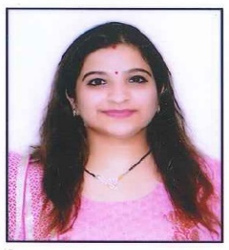**Mansi Kapoor**

**Flat 304, Sai aangan society, Dwarka mor| 7678182347| mansi.nakra@gmail.com**

To build a long- term profession as a primary teacher that will offer endless opportunities for career growth and to keep up with cutting- edge educational technologies. Enthusiastic and dedicated primary teacher with experience teaching and supporting primary level classrooms serving students with different learning styles.

**Academic Qualification**

**Somerville School, Noida**

**XIIth**- commerce with child psychology

**Xth** - Science, English, Maths, Social studies, Hindi

**Amity University, Noida**

**Bachelors of Elementary Education (B.el.ed)**

* Child Development
* Story telling
* English Foundation
* Contemporary India
* Maths
* Behavioural science
* Communication skills
* Hindi

**Work Experience**

**Indraprastha International School, Dwarka**

**Primary Teacher, March 2022- March 2023**

**Mother Teacher of class 1**

**Job Responsibilities**

* Maintaining a strong bond between parents and students.
* Subject enricher of English maths, evs and hindi
* Lesson planning and academic planning for the session
* Maintaining a comfortable and safe environment for the students.

**Gurugram Global heights school, Gurugram**

**2021 September-2022 April**

**Mother Teacher of class 2**

**Job Responsibilities**

* Subject enricher of English, maths, Evs
* Lesson planning and activity planning for the session
* Maintaining a healthy bond with students.

**Indraprastha Global School, Noida**

**2017 March - 2019 June**

**Assistant Teacher of Nursery**

**Job Responsibilities**

* Handled children and understanding the basic needs of them.
* Strengthening the concepts of children who needed additional guidance
* Helped in extracurricular activities
* Helped in daily work flow of the class

**Skills**

* Computer Proficient
* Fluent Communication skills

**Hobbies**

* Art and craft
* Photography
* Music
* dance

**Personal Details**

Date of Birth- 16.10.1994

Marital Status- Married

Daughter- 2-year-old

Nationality- Indian